Scholastic and co-scholastic report for the month of December 2021

S.No | Grade | Page No
1 | Preprimary | 1-2
2 | Grade I | 3-5
4 | Grade III | 6-7
5 | Grade IV | 8-10
6 | Grade V | 11-12
7 | Grade VI | 13-14
8 | Grade VII | 15
Pre-primary
A Study On Different Weather
PP1 & PP2 Kids are shown video to learn about weather, where they learn about the different conditions of weather like heat, rain, storm, rainbow etc... Students also learn about various kinds of clothes we wear during rainy day like raincoats, boots, umbrella etc. Students learn about the concept of big and small in the video comparing the sizes and colours of umbrellas. Students learn about rain collectors and the process of rainfall or water cycle. PP2 children learnt new terms like evaporation, condensation etc. and dabbed using colour of rainbow on, ‘A Rainbow’ using cotton buds, PP1 students made their own umbrella craft that was related to the theme of the field trip. Students were engaged doing the activity and had fun. Students made weather vane as homework related to the theme.
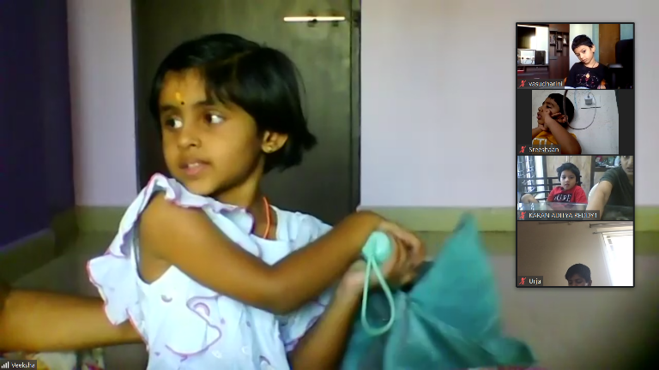
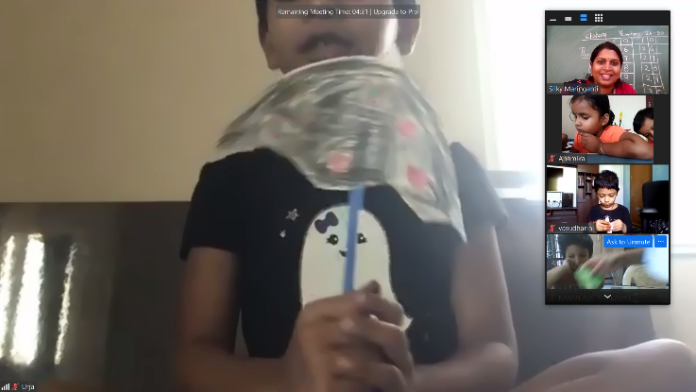
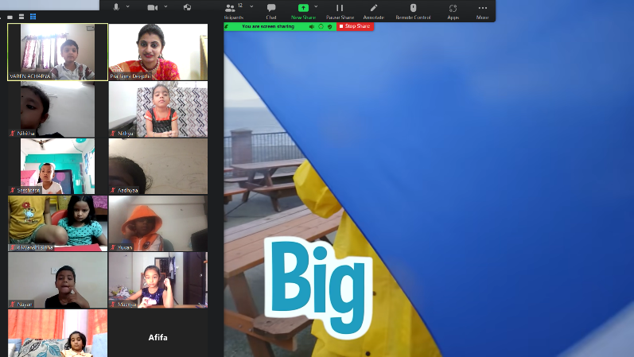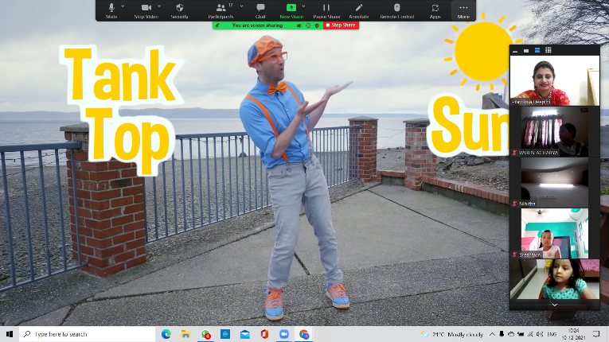
.
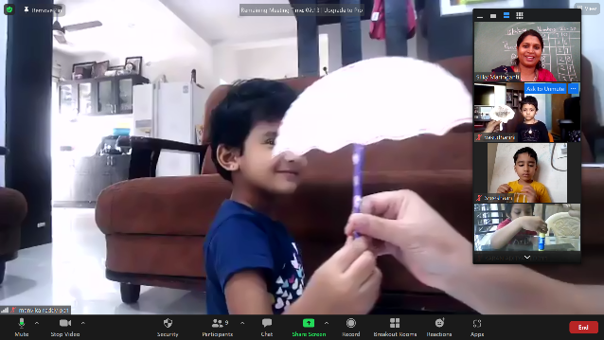
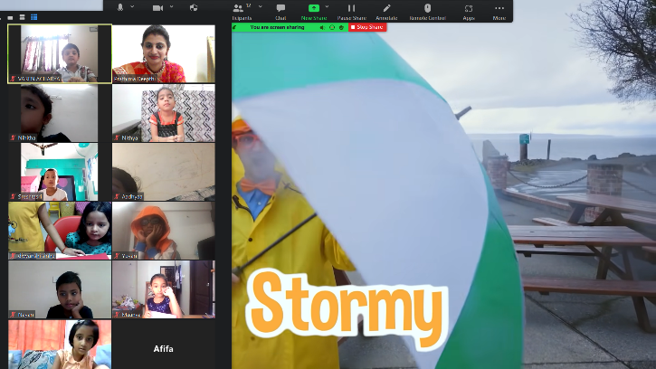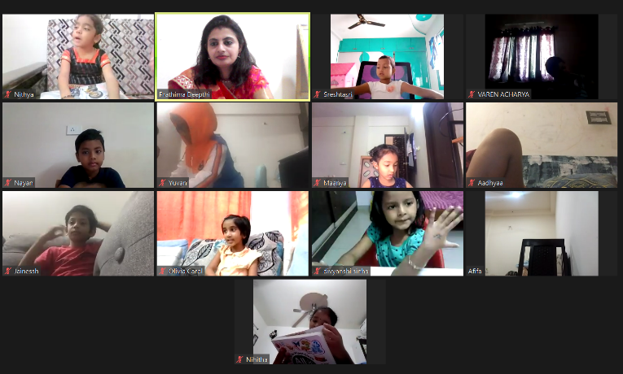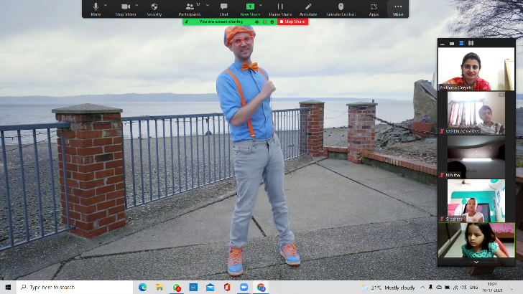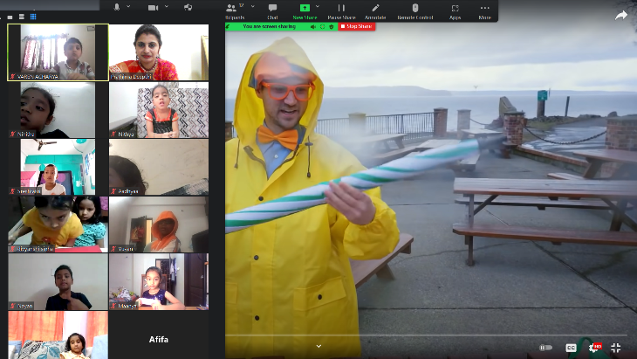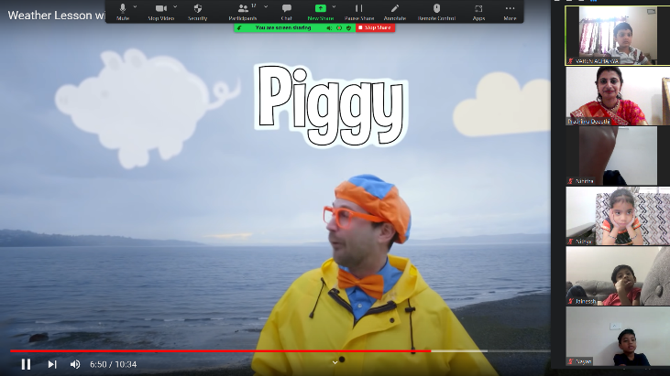
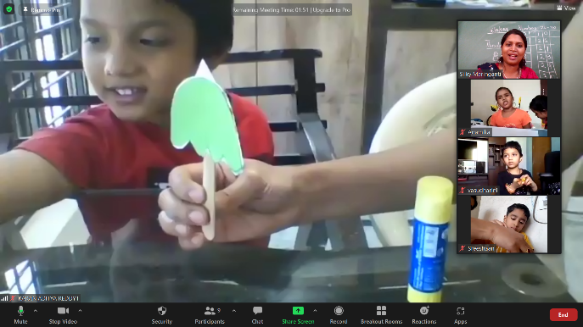
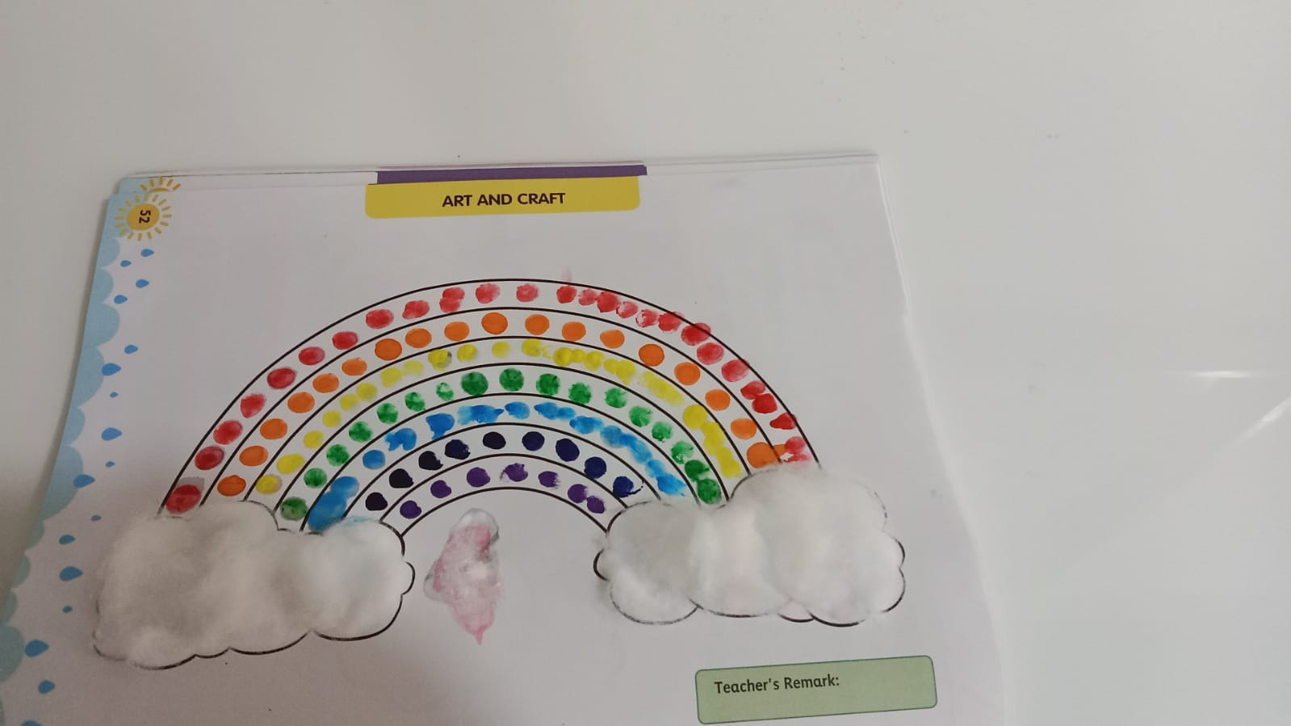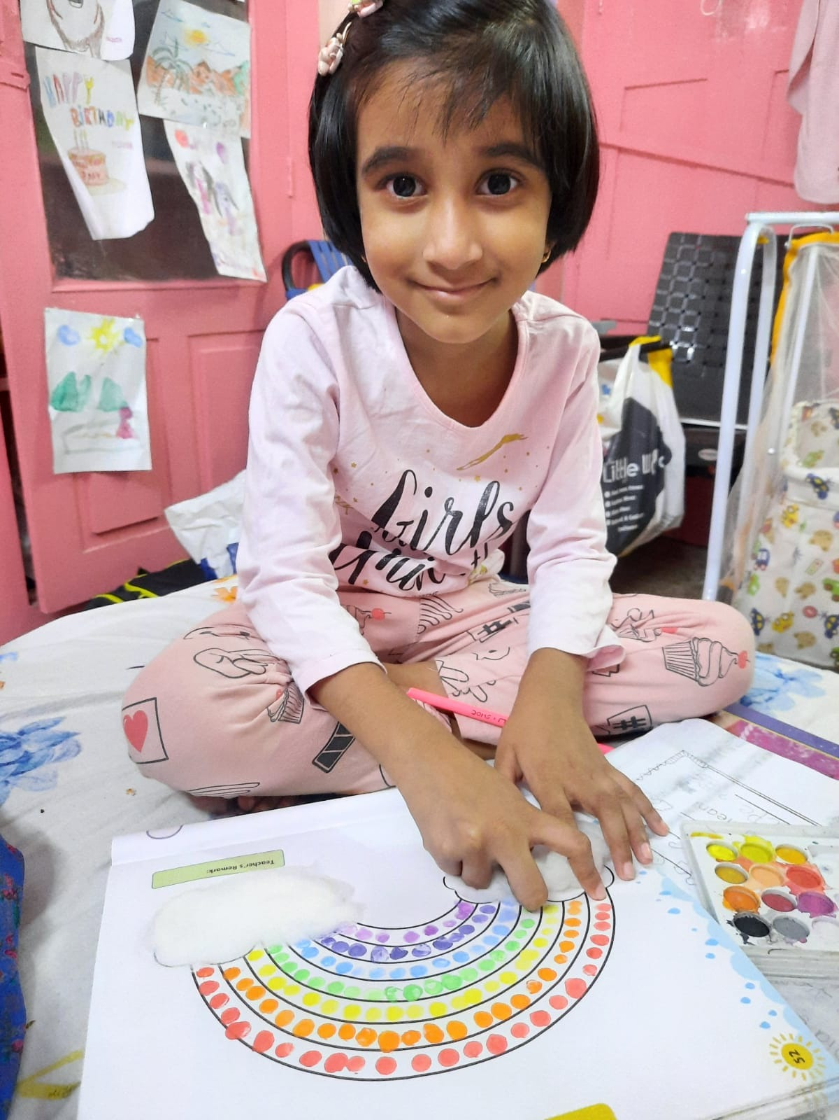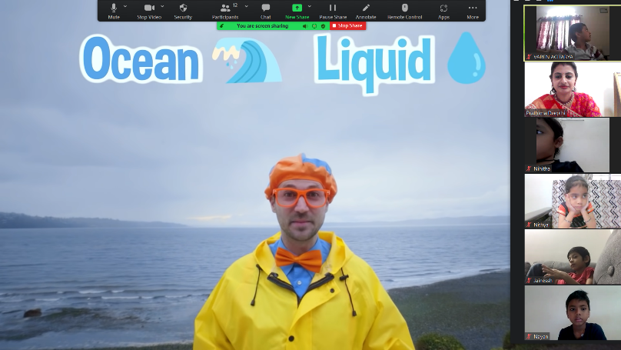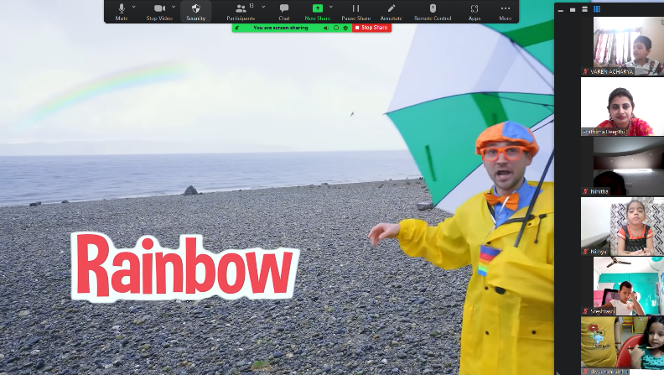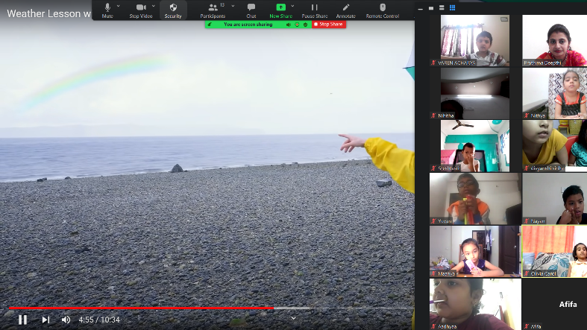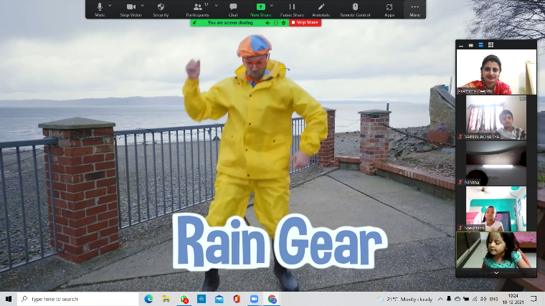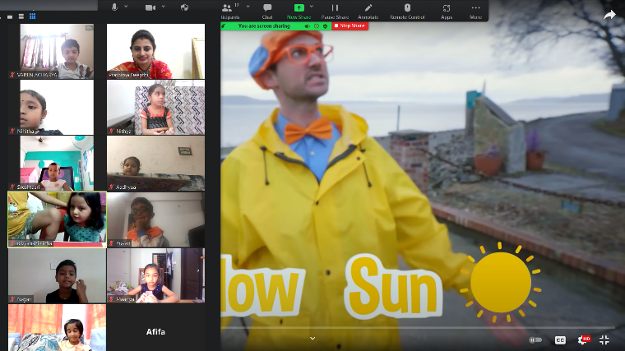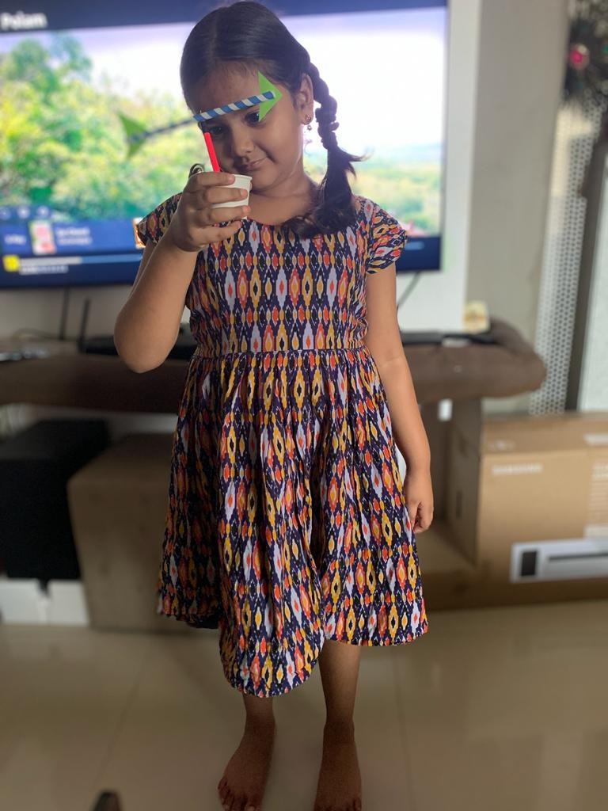
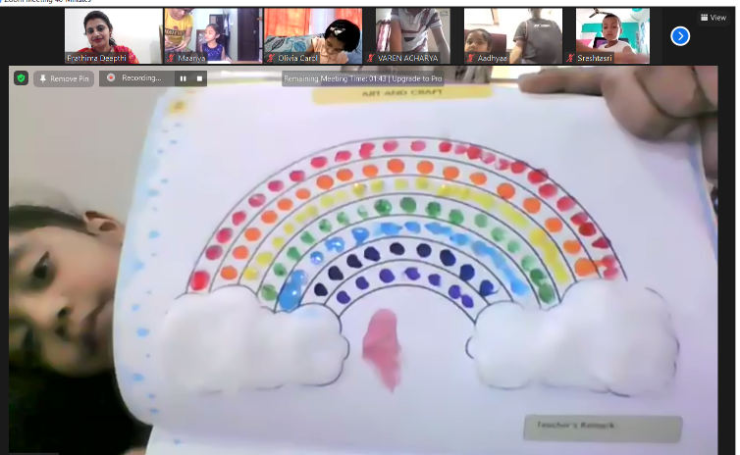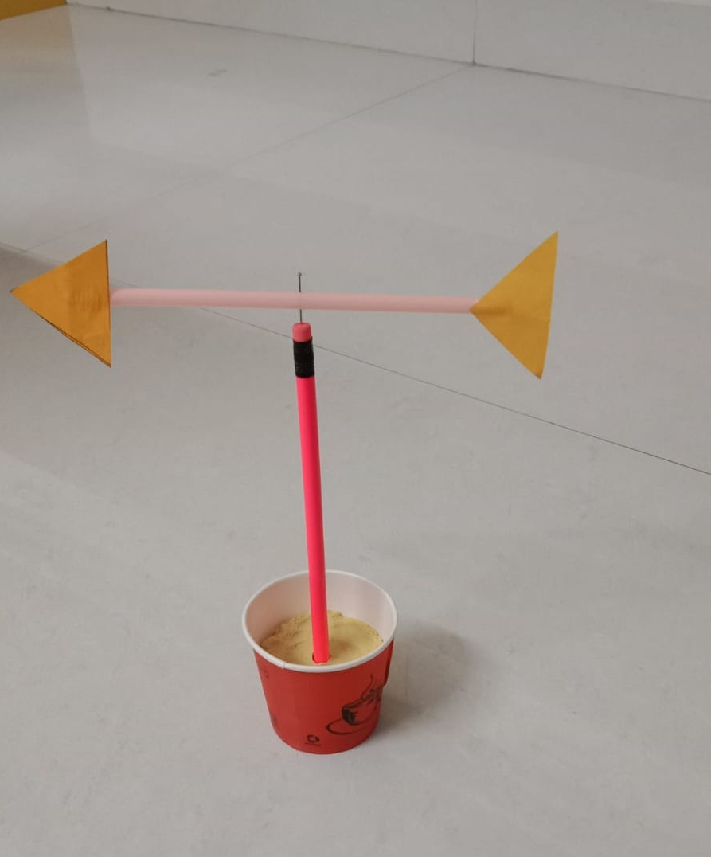

Grade I
Grade-I students of AVN Vida School were engaged in making, ‘A Fruit Salad Activity’ as part of ‘Art Integration Project’, pertaining to the on- going lesson, ‘What should Som Grow’. Preparing fruit salad is something that works well on lots of different levels. Students of Grade- I smartly dressed as ‘Junior Chefs’ explained the process of making fruit salad. Students used of different types of vocabulary that was relatable to the given topic. Most importantly, making fruit salad is fun and it is something that most children like to eat. The objective of the activity is to adapt the vocabulary and it’s the complexity. At the end, we ate the fruit salad together which is always fun in the offline classes and students presenting online prepared it and shared with their families.

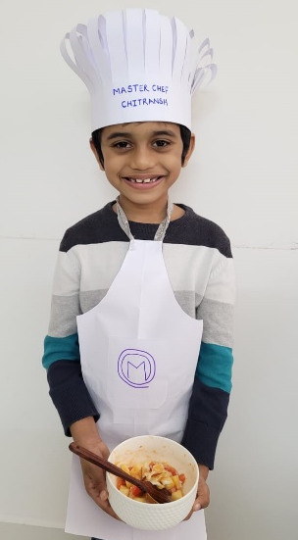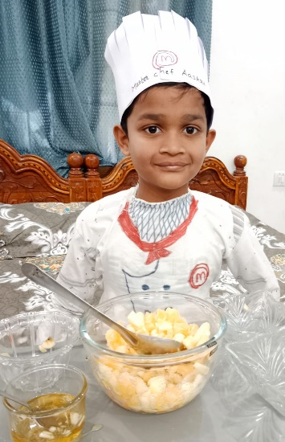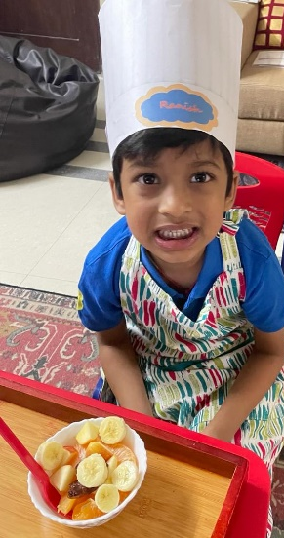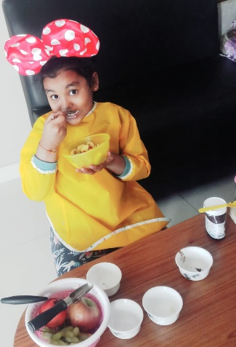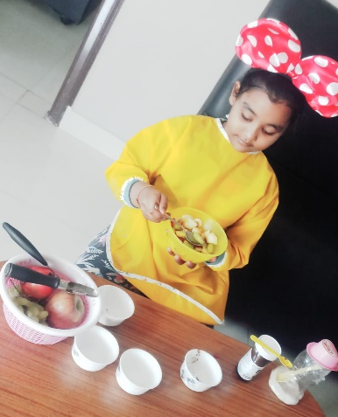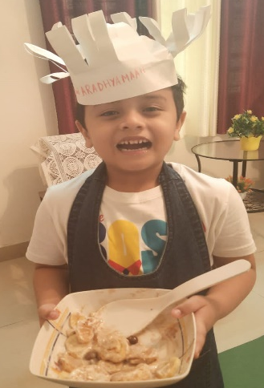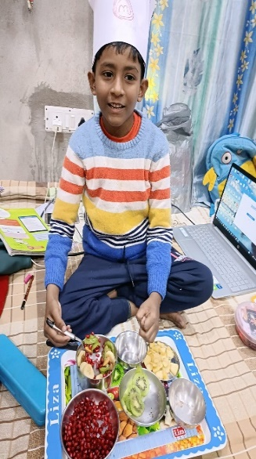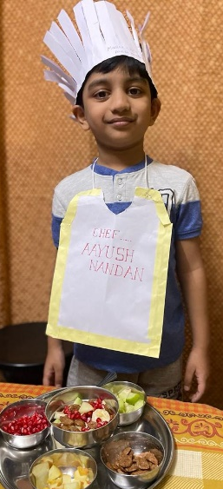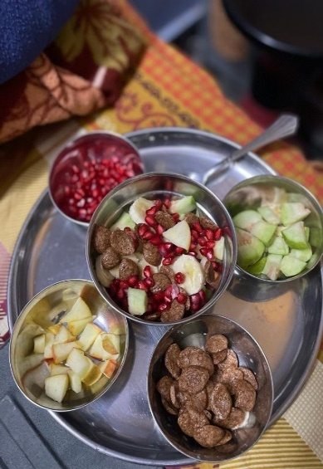

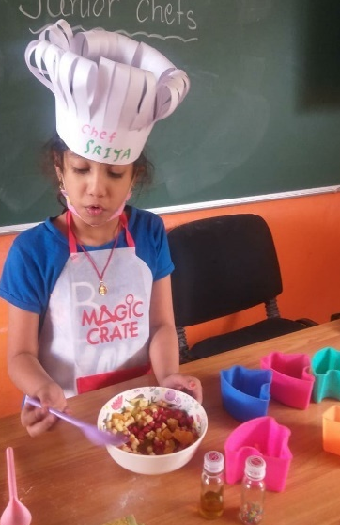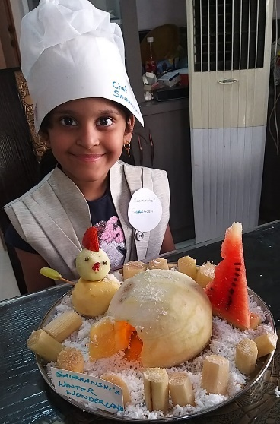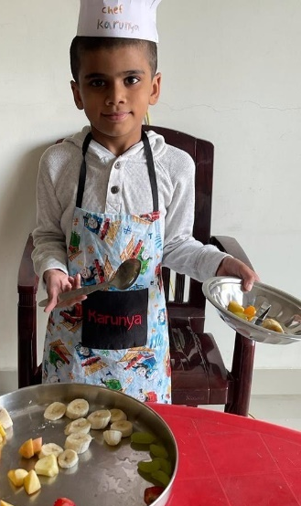
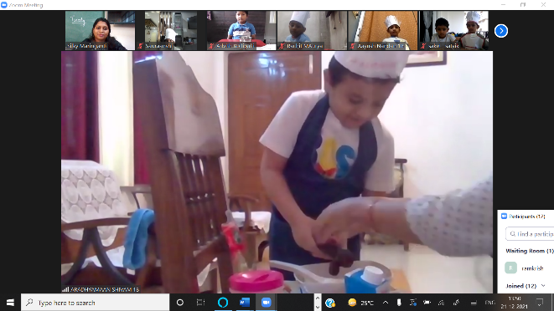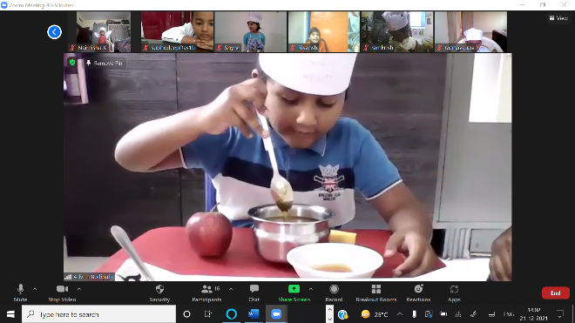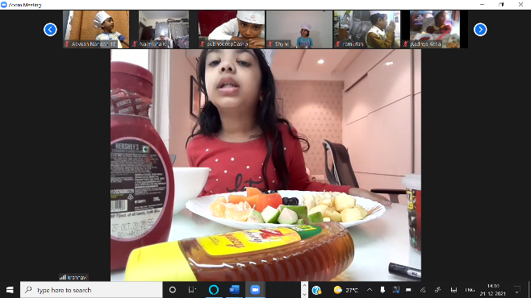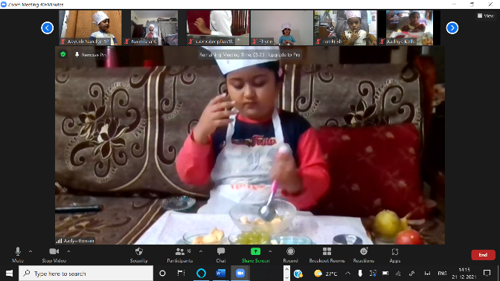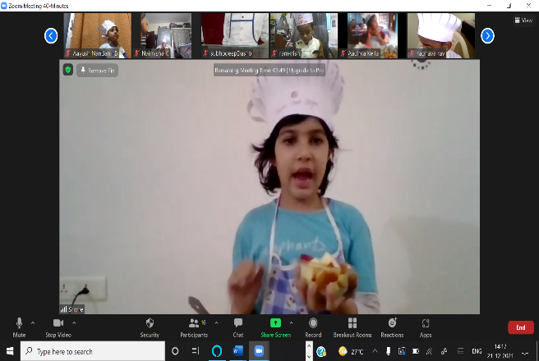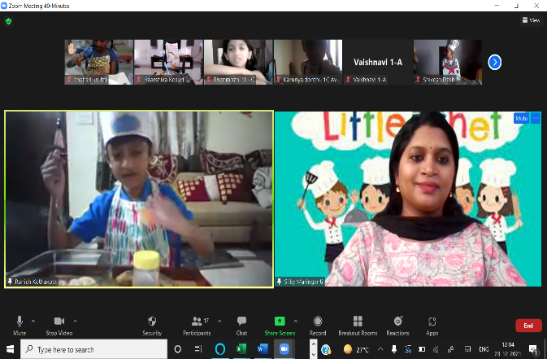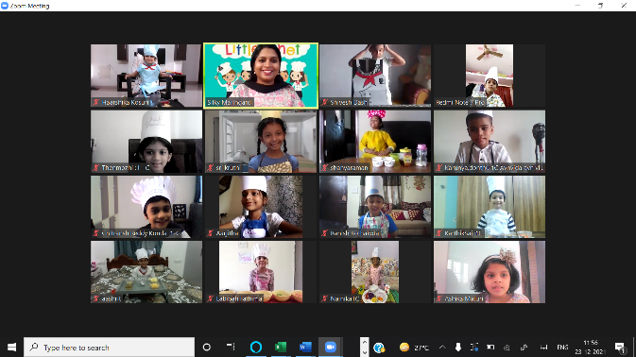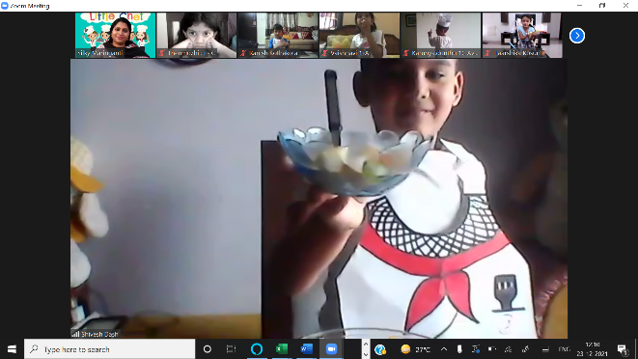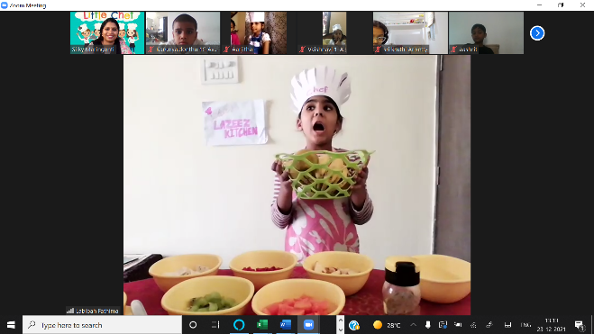

Grade III
Subject: Mathematics
- Students learnt to read out the time in hours, minutes and seconds.
- Students are able to relate the numbers in terms of hours, minutes and seconds.
- They are able to identify the difference between Ante-Meridiem and Post-Meridiem.
- They are also able to apply them while reading out the time depending on the session of the day.
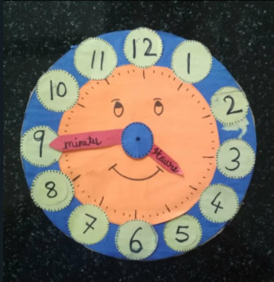

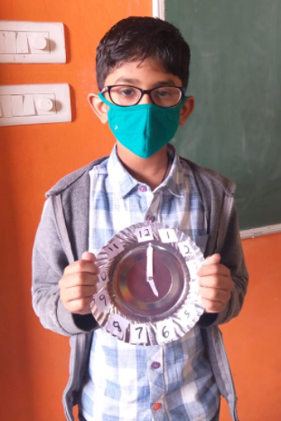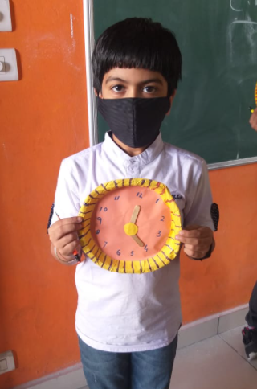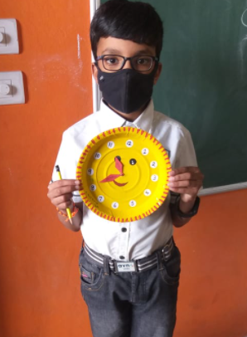

Social Science:
Social Science is a subject in which students learn about social responsibilities, relations, our country, natural phenomena’s and world around us. Students learn lot of things during discussion of different ideas based on the lesson. Different teaching methods bring out different learning objectives from students. Students actively participated in speaking activity. They prepared charts on topic of Life of Early Humans. And also few students also prepared models of early human’s home. And this activity is considered as SEA-2 .

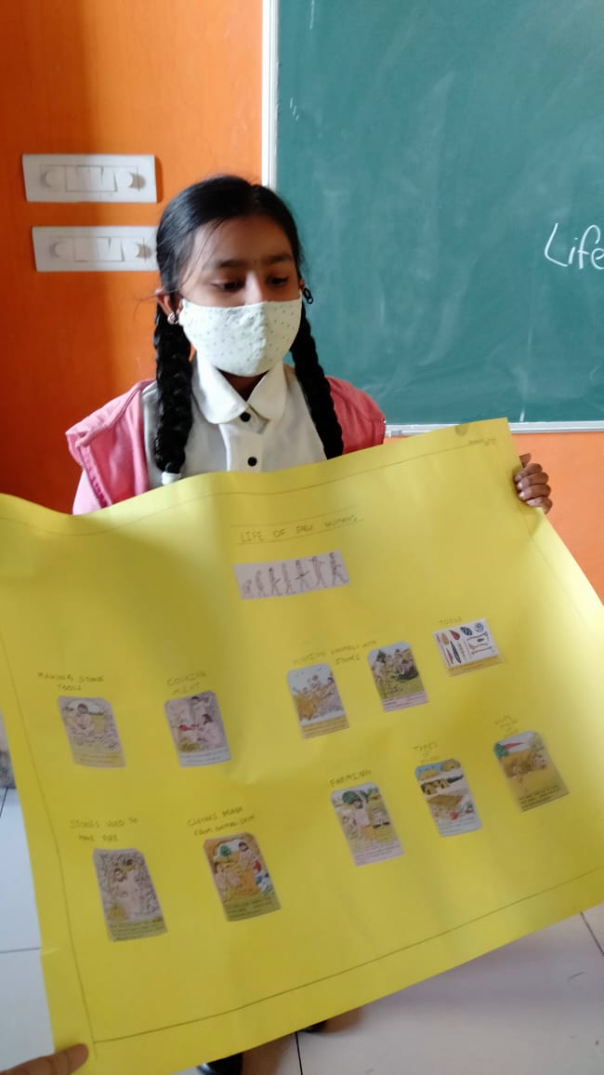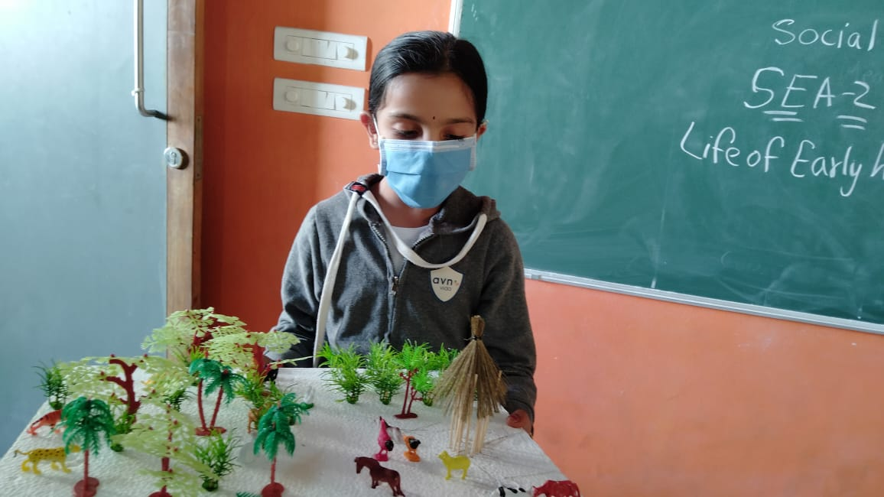

Grade IV
ACTIVITY-POSTER MAKING ACTIVITY ABOUT MIGRATORY BIRDS.
In this activity, Grade 4 students learnt about forests and wild life and about the migratory birds that migrate to different countries depending on the seasonal variations in temperature. They collected information and pictures of different migratory birds and talked about them Students understood about Bird migration and that it is the regular seasonal movement, often north and south along a flyway, between breeding and wintering grounds and that many species of bird migrate. They also could explore and find out about names of different migratory birds and could understand that Migratory birds fly hundreds and thousands of kilometres to find the best ecological conditions and habitats for feeding, breeding and raising their young. When conditions at breeding sites become unfavourable, it is time to fly to regions where conditions are better. They could also explore and collect information about birds that follow many different migration patterns. They also could understand the importance and significance of saving birds and that we all must take proper measures to help the birds live and save them from extinction. Birds are vital for our ecosystem and its balance, thus we must all keep them safe.

ACTIVITY- Gather the information about any one international day and its significance and make a poster on it.
Students of Grade V gathered and collected information about any one international day and wrote about its significance. The United Nations General Assembly designates a number of "International Days" to mark important aspects of human life and history. Students could understand that each international day offers many people the opportunity to organize activities related to the theme of the day. Organizations and offices of the United Nations system, and most importantly, governments, civil society, the public and private sectors, schools, universities and, more generally, citizens, make an international day a springboard for awareness-raising actions.
Students could gather information about working of United Nations Specialized Agencies, including UNESCO, that can also proclaim World Days. The proclamation of international days depends on their governing bodies and internal regulations.
They could also understand and got awareness about how UNESCO celebrates UN International Days related to its fields of competence, in addition to the other World Days, proclaimed by the Organization's governing bodies or other institutions. Students made beautiful and creative poster about different international days and their significance.

Grade V
Grade V students have done an activity on the Circle Graph.
- Students learnt to represent the data in the circle graph.
- Students are able to relate the circle graph with the represented data.
- They are able to interpret the data represented in the form of Circle graph.
- They are also able to differentiate the highest and lowest quantity using circle graph.

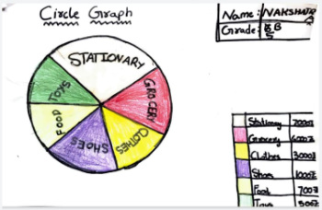
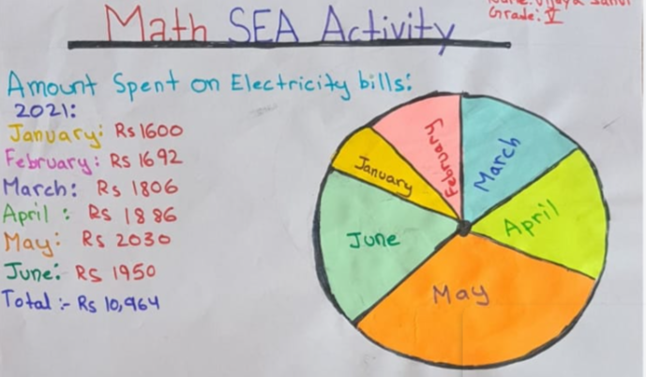
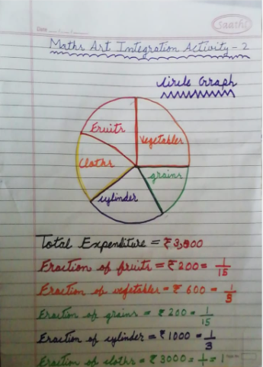
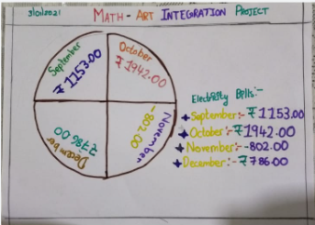

Grade VI
ACTIVITY- Individual speaking activity. Topic-Rural life is more advantageous or beneficial than urban lifestyle.
Students of Grade 6 participated in the speaking activity to voice what they think about rural livelihoods and urban livelihoods and also got an opportunity to voice out their opinions on the topic however they choose. The most powerful expression of voice is not only in thought, but in how those thoughts are shared. The opportunity to articulate their voice in the most powerful way for them that they can demonstrate evidence in their learning and understanding.
They could understand about the factors responsible for availability of different occupations undertaken in rural areas and urban areas. Students could understand and appreciate that in rural India, agriculture is the main occupation for most of the people. Apart from farming, there are some other means of livelihood as well. They spoke about the farmers in rural India, who can be divided into three categories, viz. big landlords, small farmers and landless farmers.
They also discussed about the advantages and disadvantages of rural lifestyle and urban lifestyle and compared the differences. They could understand that the Social and political life is a very important especially considering that it carries a huge value in everyday life. It deals with the working of our government, society, and basic civic sense of things, earning income and proper livelihood, hard work and how each of us are connected and effected to the society and environment we live in.
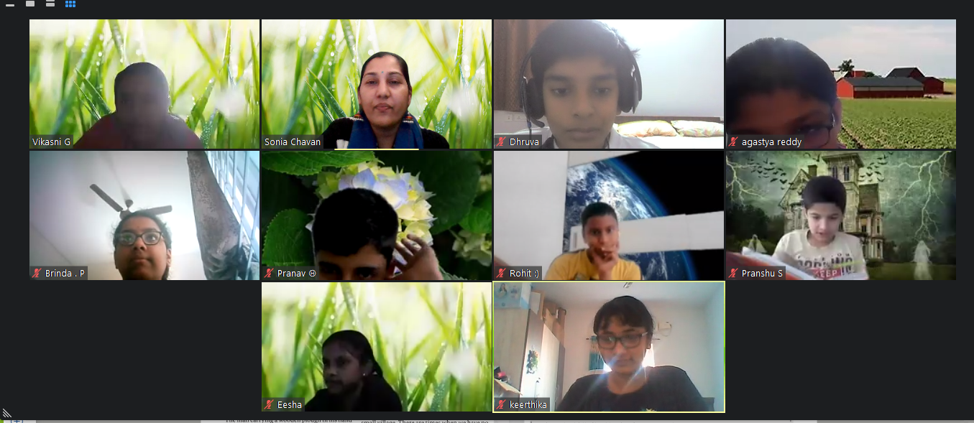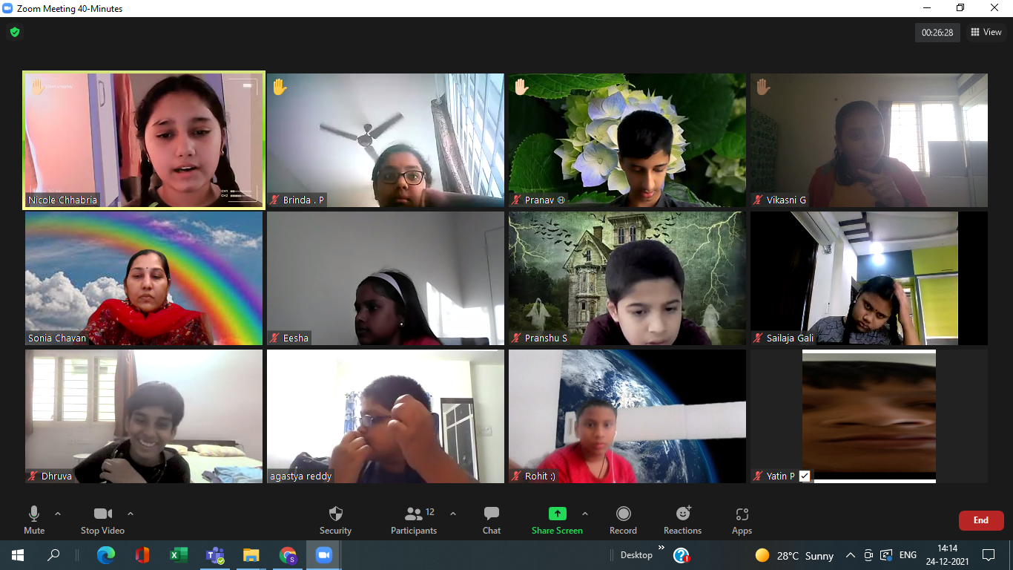

ACTIVITY- Individual speaking activity. Topic-Rural life is more advantageous or beneficial than urban lifestyle.
Students of Grade 6 participated in the speaking activity to voice what they think about rural livelihoods and urban livelihoods and also got an opportunity to voice out their opinions on the topic however they choose. The most powerful expression of voice is not only in thought, but in how those thoughts are shared. The opportunity to articulate their voice in the most powerful way for them that they can demonstrate evidence in their learning and understanding.
They could understand about the factors responsible for availability of different occupations undertaken in rural areas and urban areas. Students could understand and appreciate that in rural India, agriculture is the main occupation for most of the people. Apart from farming, there are some other means of livelihood as well. They spoke about the farmers in rural India, who can be divided into three categories, viz. big landlords, small farmers and landless farmers.
They also discussed about the advantages and disadvantages of rural lifestyle and urban lifestyle and compared the differences. They could understand that the Social and political life is a very important especially considering that it carries a huge value in everyday life. It deals with the working of our government, society, and basic civic sense of things, earning income and proper livelihood, hard work and how each of us are connected and effected to the society and environment we live in.

Grade VII
I. Activity to understand vegetative propagation in onion

Curiosity is the ability to seek and acquire new knowledge, skill and way of understanding the concept.
Students perform this activity to understand the important concept of science where they learnt that in some plants, vegetative part such as roots are responsible for producing new plants.

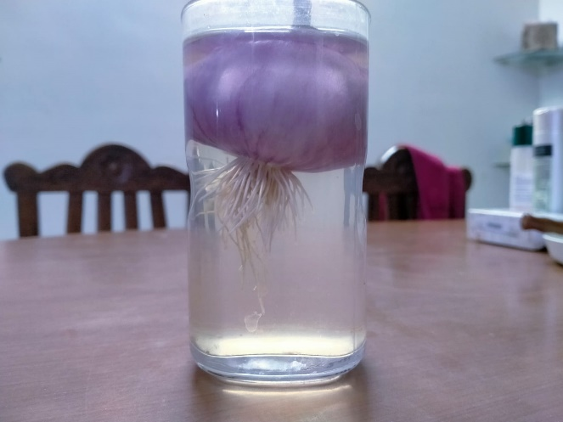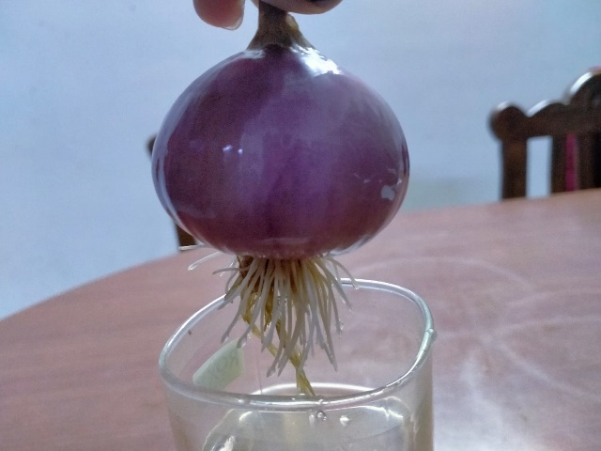

II.Newton’s disc

A Newton disc is also well-known as disappearing colour disc, a composition of colours shaped like a pie on a disc. It is majorly used to demonstrate how white light is composed of the rainbow colours. When you spin the newton's disc very fast you see the primary rainbow colours used start blending into a whole white disc.It illustrates the dispersion of light.
Student understood this important phenomenon in physics in fulfilled way in the form of craft.

